Use Case

for

Unified Academic & Student

Calendar System
Version 1.0 approved
Prepared by Group 18
LUT University
20.10.2026

Table of Contents

Table of Contents ii
Revision History ii
1. Use Case Diagram 1
1.1. Use Case Diagram 1 1
1.2. Actors, roles, goals in system 1
2. List of Use Cases 1
2.1. UC-1: Log in with LUT account 2
2.2. UC-2: View unified calendar 2
2.3. UC-3: View events & courses 2
2.4. UC-4: Fetch/Retrieve academic events from Sisu, Moodle and Time Edit 3
2.5. UC-5: Export/Synchronize calendar with external tools (Google Calendar, Apple Calendar and outlook) 4
2.6. UC-6: Collect social events with the web scraper 4
2.7. UC-7: Create/Edit/Delete personal event 5
Create/Edit/Delete personal event 5
2.8. UC-8: Receive push notifications about events and deadlines 5
2.9. UC-9: Connect external apps through the public API 6
2.10. UC-10: Filtering events & courses 7
2.11. UC-11: Create/Edit/Delete manually public event 7
2.12. UC-12: Language change 8
3. Declaration of AI use 9

Revision History

Name | Date | Reason For Changes | Version
Group 18 | 13.10.2026 | Initial draft | 0.1
Group 18 | 16.10.2026 | Completed UC-5 and UC-8 to UC-10, added the use case diagram | 0.2
Group 18 | 20.10.2026 | Version 1.0 released | 1.0

Use Case Diagram
In this use case document, different use cases related to unified calendar view will be listed and explained in more detail. Each table contains the respective use case and describes it, and its contents and gives information about possible conditions before the use case may be completed.

Use Case Diagram 1
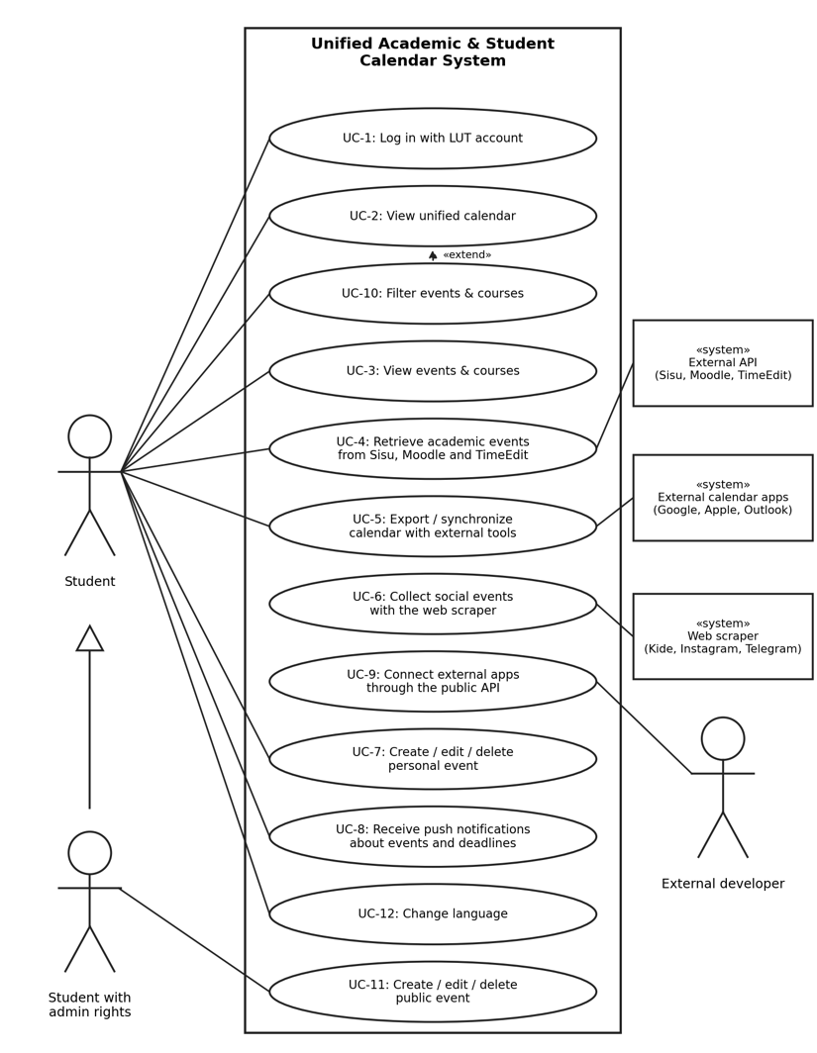
Figure 1. Use case diagram of the Unified Academic and Student Calendar System

Actors, roles, goals in system
Actor | Role and goal in the system
Student | Primary actor, logged in user who can search the courses and events, add them to calendar, add/edit/delete private events to the calendar, turn on notification, export the calendar and edit own data.
Student with admin rights | Actor with special privilege, logged in user who can search the courses and private and public events, add them to own calendar, add/edit/delete private and public events to the calendar, turn on notification, export the calendar and edit own data.
Web Scraper | Third-party program which automatically connects to the events channels and imports the events to the local database.
External API | Gives authorized access to the courses for the calendar or search query.
Local Database | Stores data about courses, public and personal events and preferences of notifications of the user.
Localization Library | Stores three main languages of the interface. Have three languages options – Finnish, Swedish and English.

List of Use Cases
UC 1: Log in with LUT account
UC 2: View unified calendar
UC 3: View events & courses
UC 4: Fetch/Retrieve academic events from Sisu, Moodle and TimeEdit
UC 5: Export/Synchronize calendar with external tools (Google Calendar, Apple Calendar and outlook)
UC 6: Collect social events with the web scraper
UC 7: Create/Edit/Delete personal event
UC 8: Receive push notifications about events and deadlines
UC 9: Connect external apps through the public API
UC 10: Filtering events & courses.
UC 11: Create/Edit/Delete manually public event
UC 12 Language change

UC-1: Log in with LUT account

ID | UC 1
Use case name and version | Log in with LUT account
Actors | Students
Preconditions | Credentials provided by university, online connection
Description | After opening the application there will be a login section where you need to put your credentials for logging in the app.
Exceptions | If credentials don't work, contact your IT department for technical support
Postconditions | After the app is opened and you are on the main page (search view)
Supplemental information | Any other technical questions -> contact IT department

UC-2: View unified calendar

ID | UC 2
Use case name and version | View unified calendar
Actors | Students
Preconditions | Download the app & working login credentials
Description | View options: Month, week, day. Task list: notifying daily events, lectures. Search options for courses and events
Exceptions | Not searching for courses & events leads to preview not being shown
Postconditions | After searching there will be search results below the search bar
Supplemental information | Without search there won't be courses and events shown

UC-3: View events & courses
ID | UC 3
Use case name and version | View evens & courses
Actors | Students
Preconditions | There are courses/ events available to be chosen for the calendar view
Description | In the scheduler page you can search for lectures & events. Add or delete them from the calendar preview. Courses and events can be opened for more details. When you are happy with your preview you can save that preview into the main calendar and that will become the main calendar.
Exceptions | If nothing is chosen for view, it will be empty
Postconditions | After building up the view of your choice you should now have a view saved which would be your main calendar view
Supplemental information | The view will change depending on the filtering in calendar for example Month or week view

UC-4: Fetch/Retrieve academic events from Sisu, Moodle and Time Edit
ID | UC 4
Use case name and version | Fetch/Retrieve academic events from Sisu, Moodle and TimeEdit
Actors | Main actor: Student, Secondary actor: Sisu, Moodle and Time edit API
Preconditions | A student managed to successfully log in to the system with credentials from LUT. API to Moodle, Sisu and Time edit are accessible, and data is available. Available internet connection.
Description | After successful authentication, the system will connect to external API and check logs with local database. This will allow the user to search for the courses. If the user has already saved the calendar, the local database will showcase the results in My Callendar or Callendar Preview.
Exceptions | - Fail to fetch the data from API due to server issues or broken API (code 500) - Gives the student information “Fail to synchronize data, please refresh”.  - API gets wrong credentials and returns code 401 or 403. Students get information to contact the LUT IT department and to log in again later.  - Database connection lost or down – Student gets information to log in again later.  - Student´s search shows no result – Student gets a message “No courses were matching”.
Postconditions | Success: Student can browse the courses and add them to the calendar. Database is updated.  Fail: Student can see previously added courses in the My Callendar view or Preview Callendar. Database is not corrupted with partially fetched data.
Supplemental information | Queries should be displayed under two seconds' time. The database is updated every 10 minutes.

UC-5: Export/Synchronize calendar with external tools (Google Calendar, Apple Calendar and outlook)
ID | UC 5
Use case name and version | Export/Synchronize calendar with external tools (Google Calendar, Apple Calendar and Outlook)
Actors | Main actor: Student, Secondary actor: External calendar applications (Google Calendar, Apple Calendar and Outlook)
Preconditions | A student managed to successfully log in to the system with credentials from LUT. The student has events in calendar. For synchronization, the student has an account in the external calendar application.
Description | You can choose the My Calendar menu to view the calendar which can be exported to different calendars by pressing a button
Exceptions | If the connection to the external calendar fails or the student does not give permission, the system tells the student that it could not connect and asks to try again.  If there are no events in My calendar, the system tells the student that there are no events to export.  If the export or the synchronization fails, the system tells the student to try again.
Postconditions | Success: Events of the student appear in the chosen external calendar (export) and stay up to date (synchronization). Fail: The calendar in the system is not changed and no partial data is sent to the external calendar.
Supplemental information | Personal events are exported only to the calendar of the same student and are not shared with other users. Supported applications are Google Calendar, Apple Calendar and Outlook. Whether synchronization is one-way or two-way is to be confirmed with the client.

UC-6: Collect social events with the web scraper
ID | UC 6
Use case name and version | Collect social events with the web scraper
Actors | A third-party tool (scraper)
Preconditions | Before using a web scraper, data that will be collected must follow GDPR, regulations and laws.
Description | Web scrapers will automatically scan and export data from websites where it is connected and bring that data into the calendar view app.
Exceptions | -
Postconditions | You should have a list of events after fetching event data in the calendar
Supplemental information | The tool must not scrape information that is forbidden by law to collect. Data collection containing personal data might trigger GDPR privacy laws

UC-7: Create/Edit/Delete personal event
ID | UC 7
Use case name and version | Create/Edit/Delete personal event
Actors | Primary: Student. Secondary: Local database, calendar system
Preconditions | A student managed to successfully log in to the system with credentials from LUT. My calendar database is operational.
Description | On top menu is visible button which is opening the event creation editor. The view allows the user to fill out the form, check validation, and save the event to the personal calendar. The event can be also deleted. After pressing the delete button, the unsaved event disappears. Students should see personal events as a list under the form and be able to refresh the list. Clicking on the event on a list allows the event to be edited or deleted. Edit button prefills the form for additional changes. The delete button is deleting the event from the database. Student is first presented with the question “Are you sure to delete this event?” Yes/No. Pressing yes will delete the personal event from the local database and calendar view. The Save button automatically saves the event to the user's calendar.
Exceptions | - Validation error on save – student sees the red notification with the information “The end date cannot be before the start date”, “The title is mandatory” etc.  - Aborting delete – when a student accidentally clicks delete and chooses to abort the operation, the system stops delete of the event.  - Fail on Save or Delete or Edit – System displays information to try again.
Postconditions | Success: New, updated, or deleted personal events are visible in the calendar, list of events, and in the database.  Fail: No partially saved events in the database.
Supplemental information | There must be second confirmation of deleting the event to avoid accidental deletion. Refresh the list button must fetch the data in less than 0.5 sec.

UC-8: Receive push notifications about events and deadlines
ID | UC 8
Use case name and version | Receive push notifications about events and deadlines
Actors | Primary: Student. Secondary: Local database, calendar system
Preconditions | A student managed to successfully log in to the system with credentials from LUT. The student has courses or events in My calendar.
Description | Inside the calendar page there is a notification panel. User can choose the course and open drop-down menu and turn on or off the notifications. The system sends a push notification to the student before a lecture, an event or an assignment deadline in the calendar. Notifications are shown inside the application and not by email. The student can see them in the notification panel.
Exceptions | If notifications are turned off for the course or event, the system does not send notifications for it.  If a notification cannot be delivered because the student has no connection, the system shows it in the notification panel when the student opens the application again.  If saving the notification settings fails, the system displays information to try again.
Postconditions | Success: The notification settings are saved in the database and the student gets notifications about the chosen courses and events.  Fail: The previous notification settings stay in use.
Supplemental information | No emails are used for notifications. Planned downtime is announced with a push notification and a web banner two days before.

UC-9: Connect external apps through the public API

ID | UC 9
Use case name and version | Connect external apps through the public API
Actors | Primary: External developer. Secondary: Local database, calendar system
Preconditions | The public API is released (planned for the third release, Q3 2027). The developer has access rights to the API (for example an API key).
Description | An external developer builds an own application that connects to the system through the public API. The application sends a request with its access rights. The system checks the access rights and returns the allowed calendar data in a standard format. Personal events of students stay private.
Exceptions | If the access rights are missing or wrong (code 401 or 403), the system does not return data and tells the developer that access was denied.  If there are too many requests in a short time, the system rejects the requests and tells the developer to try again later.  If the system or the database is not available (code 500), the system tells the developer to try again later.
Postconditions | Success: The external application receives the requested data.  Fail: No data is returned to the external application.
Supplemental information | The public API belongs to the third release (MF9). The API must be secure and follow the same data protection rules as the system, so personal events are never shared. The details of the API (available data, limits) are defined in the SRS.

UC-10: Filtering events & courses
ID | UC 10
Use case name and version | Filtering events & courses.
Actors | Primary: Student. Secondary: Local database
Preconditions
Description | In scheduler you are able to filter courses and events. It will be visible in search results under the event search box. The student can select filters, for example the type of the event (academic, student event or personal event) or the course. The student can clear the filters to see all events again.
Exceptions | If no events match the selected filters, the system tells the student that no events match the filters.  If loading the filtered data fails, the system displays information to try again and keeps the previous view.
Postconditions | Success: Only the events and courses that match the filters are shown in the calendar and in the search results.  Fail: The previous view remains unchanged.
Supplemental information | Filtering uses the data in the local database, so the results should be displayed under two seconds like in UC-4. Filters do not change or delete any events.

UC-11: Create/Edit/Delete manually public event
ID | UC 11
Use case name and version | Create/Edit/Delete manually public event
Actors | Primary: Student with special/admin rights. Secondary: Local database, calendar system
Preconditions | A student managed to successfully log in to the system with credentials from LUT. My calendar database is operational.
Description | On top menu is visible button which is opening the event creation editor. Students with special rights will see a set of two buttons – Create personal events and create public events. The view allows the user to fill out the form, check validation, and save the event to the local database as possible to be imported by another user's event. The event can be also deleted. After pressing the delete button, the unsaved event disappears. Students with the rights should see all events as a list under the form and be able to refresh the list. Clicking on the event on a list allows the event to be edited or deleted. Edit button prefills the form for additional changes. The delete button is deleting the event from the database. Student is first presented with the question “Are you sure to delete this event?” Yes/No. Pressing yes will delete the public event from the local database and calendar view of all logged in students. The Save button automatically saves the event to the database.
Exceptions | - Student fails to choose the public event button – System asks what type of event it is public or private (if private UC:7). Then save the event.  - Validation error on save – student sees the red notification with the information “The end date cannot be before the start date”, “The title is mandatory” etc.  - Aborting deletes – when a student accidentally clicks delete and chooses to abort the operation, the system stops delete of the event.  - Fail on Save or Delete or Edit – System displays information to try again.
Postconditions | Success: New, updated, or deleted public events are visible in the calendar – if added to the calendar through search option, list of events, and in the database.  Failure: No partially saved events in database.
Supplemental information | There must be second confirmation of deleting the event to avoid accidental deletion. Refresh the list button must fetch the data in less than 0.5 sec.

UC-12: Language change

ID | UC 12
Use case name and version | Language change
Actors | Primary: Student. Secondary: Localization library
Preconditions | At least the calendar system login page is loaded. Libraries are present in the system.
Description | Language change allows the user to change menu and titles of the views into desired language from the list: English, Finnish, Swedish.
Exceptions | Missing label in the UI – UI shows Finnish language. Missing other labels – the text is shown in Finnish.
Postconditions | Success: Translated UI.  Fail: The menu stays in the previous language version.
Supplemental information | The available languages are English, Finnish and Swedish. Finnish is the default language if a label is missing. The language change applies to the menus and the titles of the views, not to the content of the events. Language change is not yet in the Vision and Scope, so it needs a new Major Feature (MF10) before it is final.

Declaration of AI use
For that assignment, ChatGPT (https://chatgpt.com/) was used for supplementary reading and research, and the same LLM was also utilised for linguistic purposes to enhance text readability.

